General analysis and design
To get started lets look at the requirements one by one. For each requirement we will enhance the design to incorporate the feature.

Interact with the satellites failsafe mode from a desktop computer via a graphical user interface. GUI must be easy to get up and running.
Lets implement a java swing GUI that communicates with the satellite through a serial connection.

Interact with the satellite from a unix terminal.
We could use the same java application to take in arguments from the command line and communicate with satellite through the same serial connection.

Provide flexible tools for specific tasks, such as uploading new software, running tests and performing diagnostics
The failsafe software has a set of basic commands which by themselves are of limited use but becomes powerful when combined. As we can not know which failures might occur in the future, it is critical that there is a flexible way of combining these commands in conditionals and loops.

One solution is to combine the commands in the GUI with GUI elements for a command, a command sequence, an if statement and its branches, a loop statement and its body and so forth. This solution is hard to extend with a switch-statement in two years time when someone needs it – and without the source code practically impossible.

Luckily, we do not need a GUI solution for this. Conditionals and loops have already been implemented many times in script languages such as Ruby, Python or TCL and we can use these to achieve flexibility.

But how do we communicate with the satellite over a serial connection from a Ruby script? Well we could implement the serial connection in ruby of course, but that would mean two things. One, we would have to implement a serial connection for a language before it could be used to write satellite scripts which is inflexible. Two, there would exist several implementation of the serial connection which is errorprone.

Is there anything all scripting languages have in common? Yes they do, they all run in a unix environment. All languages have built-in libraries for running a terminal command and manipulating its output. So, we could implement a unix program “FSClient” that the scripts can pass arguments to and retrieve output from. FSClient will handle the serial connection to the satellite. The GUI will use FSClient for its serial connection also.

Ok, all good, except this solution is not compatible with Windows which is unacceptable. We want to handle the serial connection from one place only and we want to execute scripts from unix and windows. So does unix and windows have anything in common? Yes, they both implement the TCP protocol, so we will use that. We will let a server “FSServer” handle the serial connection to the satellite. FSServer listens for TCP connections. Whenever FSClient or FSGui needs to communicate with the satellite it has to go through FSServer. Now we effectively have a TCP interface to satellite enabling us to write clients in any programming language and operating system that support TCP.

FSServer must be aware of multiple TCP clients and ensure that commands from various TCP clients are not executed at the same time. This challenge will be analysed in the FSServer Chapter.

To see a graphical representation of the state of the satellite and its subsystems.
The failsafe software has a command called HEALTH_STATUS which will return a set of numbers representing the state of the subsystems. These numbers will be interpreted to temperature, on/off etc in FSGui.

Chosen design
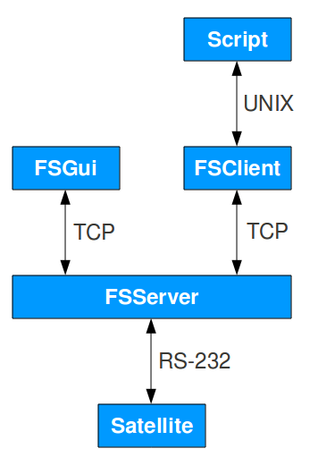
The solution consists of four key parts:
- FSServer
  - Serial connection to the satellite
  - Send satellite response back to TCP clients
  - Ensure atomicity of commands
- FSClient
  - Unix program
  - A TCP client to FSServer
  - Request/Response for other unix programs / scripts
- FSGui
  - Swing GUI
  - No installation and runs on unix and windows desktops
  - Send satellite commands
  - Look at a graphical representation of the state of the satellite

- Scripts
  - Any script or programming language that can execute unix commands
  - Combine satellite commands in conditionals and loops

